* **Overview of BI and BW**
* **Architecture of BI**
* **Components of BI**
* **BI Environment**
* **BI catalog Structure**
* **InfoPath**

**Introduction SAP BI**

**Details**

Last Updated: Friday, 05 August 2016 07:08

Business intelligence (BI) is an application used for giving meaning to raw data that an organization has. The raw data is cleansed, stored and applied with business logics to be useful for enterprise users to make better business decisions. This data can be presented in the form of reports and can be displayed in the form of tables, charts etc. which is efficient and easier to analyse and make business decisions.

During all business activities, companies create data about customers, suppliers and internal activities. Based on these data’s, employees of various departments like HR, Finance, Accounting, Marketing etc. prepare their work plan.

Business Intelligence spans a varied set of toolset, of which the Data Ware House consolidates and loads the data from the different Source Systems, while reporting tools like Query Designer, Web Application Designer, and Analyzer are majorly used to create reports which display the data consolidated by the Datawarehouse for analysing purpose.

Business Intelligence is a SAP product which majorly focuses on providing its customers/organizations with a user friendly and very useful form of representing data that could be helpful for analyses purpose and making business decisions.

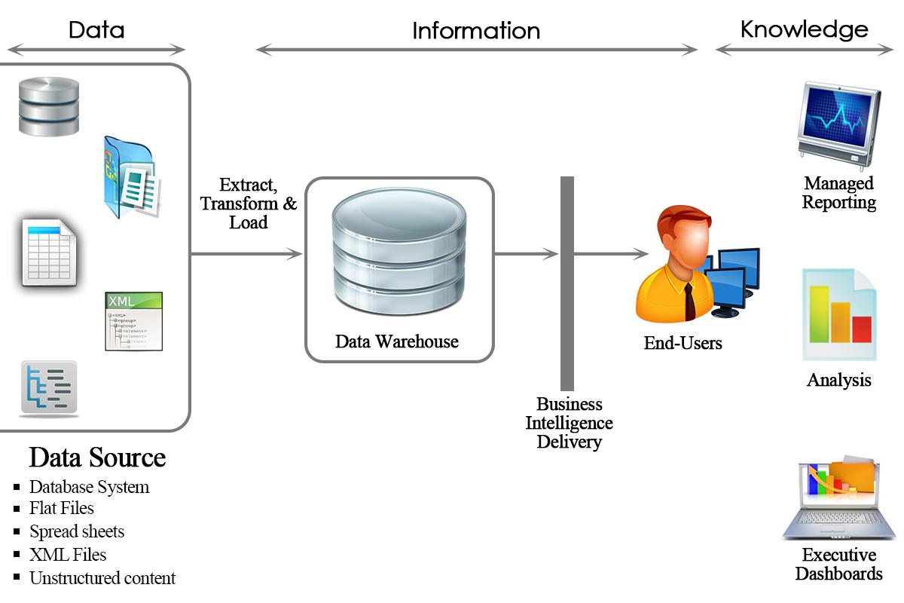

In summary, Business Intelligence tools transform raw data into reports which used for decision making and business forecasting.

**Why do we need Datawarehouse & BI ?**

Organizations have different kinds of data such as finance, Human resource, customer, supplier data etc., which can be stored on different kinds of storage units such as DBMS, excel sheets, SAP R/3 systems etc...Even the company's internal data is often distributed across many different systems and is not particularly well formatted.

[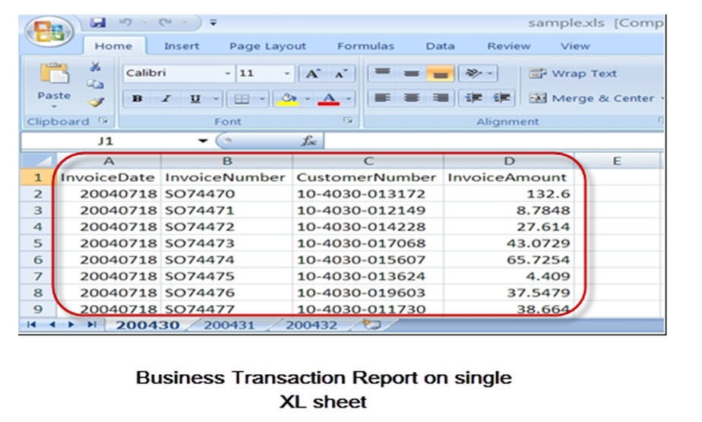](http://cdn.guru99.com/images/sap/SAP_BI/sap_bi_1_2.jpg)

A Data Warehouse can help to organize the data. It brings together heterogeneous Data Sources which are mostly and differing in their details. Using BI Tools one can derive meaningful reports

**What makes SAP BI more effective BI tool?**

* Single point of access to all information is possible through BI. The data from various sources can be accessed at the single place(i.e BI).
* Data collected from various sources are presented in the form of reports which is efficient for analysis of the data at a high level.
* SAP BI provides easy to use GUI and better formatting
* Some of the key functionality that makes SAP BI better than rest is its ability to analyze **multidimensional** data sources in both web and MS office environments, flexible dashboards, mobility and a flexible, scalable BI platform.
* SAP BI is known for its awesome **query performance**, while requiring little administration
* **Mobile BI** for end users on the go
* **Easy Integration** with other platforms

**SAP BI/ Data Warehouse Vs. OLTP systems:**

**OLTP(Online Transaction Processing):**

These systems have detailed day to day transaction data which keeps changing. For example, R/3 or any other database.

**OLAP(Online Analytical Processing):**

These systems have data for analysis purpose. The input for this system is from OLTP systems. The data from the OLTP systems is made use to prepare the data for analysis purpose.

Business Intelligence is an OLAP system.

|  |  |  |
| --- | --- | --- |
|  | **OLTP Systems** **(Operative Environment)** | **DWH/OLAP Systems(Informative Environment)** |
| Target | Efficiency through automation of business processes | Generating Knowledge (Competitive Advantage) |
| Priorities | High availability, higher data volume | Simple to use, flexible access to data |
| View of Data | Detailed | Frequently aggregated |
| Age of Data | Current | Historical |
| Database operations | Add, Modify, delete, update and read | Read |
| Typical data structures | Relational(flat tables, high normalization | Multidimensional Structure |
| Integration of data from various modules/applications | Minimal | Comprehensive |
| Dataset | 6-18 months | 27 years |
| Archiving | Yes | Yes |

**Overview of SAP BI Architecture**

**Details**

Last Updated: Sunday, 04 September 2016 16:00

Before we learn more about SAP BI Architecture, lets learn about

**Conceptual Layers of Data Warehousing with BI**

[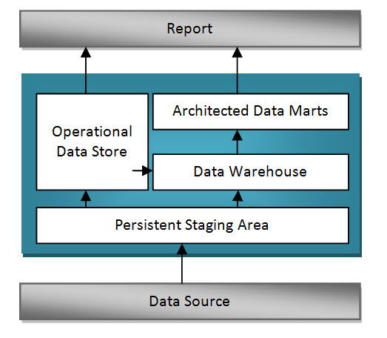](http://cdn.guru99.com/images/sap/SAP_BI/sap_bi_2_1.jpg)

**Persistent Staging Area**

The data extracted from the Source Systems first enters into the Persistent Staging Area. The data at this layer is the raw data which is in unchanged form. The data is consolidated and cleansed only in the next layers.

Staging area is a temporary table that holds the data and connects to work area or fact tables.  In the absence of staging area the data load will have to go from the OLTP system to the OLAP system directly which hamper the performance of OLTP system.

**Data Warehouse Layer (DWH Layer)**

Data from the Persistent Staging Area is loaded into the DataWareHouse Layer. It has Corporate information repository. Data in this layer is stored for a longer period.i.e,Entire History data (for example, last 5 years data) is stored here in this layer.No aggregation of reporting-relevant data;the granularity of the data stored in this layer is at line-item (detailed) level.

**Operational Data Store Layer**

Data is loaded to an Operational Data Store Layer very frequently on a continuous basis from the source systems. Hence the data in this layer contains all the changes to the data that was done throughout the day. Data from Operational data store later can be loaded to the Datawarehouse layer at particular timings (say end of the day) to update the date in Datawarehouse Layer. This Operational Data Store Layer can also be used in case of any emergencies when the data in the datawarehouse and datamart layers are lost. In such situations data can be loaded from the Operational Data Store layer to the Data Warehouse Layer and Data Mart Layer. ODS is not based on star schema model but they are in a flat files format.

**Architected Data Mart Layer**

Architected Data Mart Layer also known as Infocube. It is designed to store summarized and aggregated Data for long period of time.  Data from the Data Warehouse Layer is loaded into the Architected Data Mart Layer. It is used in Analysis and reporting. The data is at a high level relevant for creating reports displaying these data. Data manipulation with business logic is done at this layer. It consists of a central fact table(Key Figures) surrounded by several dimension tables, it is used to support BI queries

**Key Components of SAP  BI System:**

Business Intelligence is a core component of SAP NetWeaver. The figure below shows the key components of a BI system.

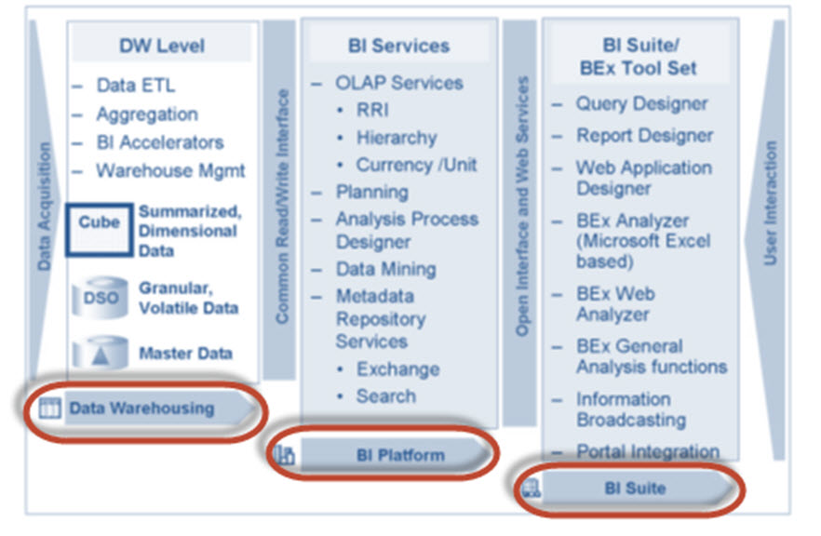

* ***Data warehousing*** – This is mainly to Extract, Transform and Load data from Source systems.
* ***BI platform*** – The BI platform layer contains BI services to support complex analysis tasks and functions. It contains the Analytic Engine, which processes the data requested through BEx analysis navigations. Its interface allows entry and manipulation of data as part of BI Integrated Planning. It also has special analysis tools such as the Analysis Process Designer (APD) and the Data Mining which provide analysts at your company with the tools to merge, mine, pre-process, store, and analyse data.
* ***BI Suite*** – These tools helps in creating reports for analysis purpose.It contains the Business Explorer (BEx) which provides flexible reporting and analysis tools.

            The following areas in the Business Explorer can be used for Data Analyses:

1. BEx Analyser (Microsoft Excel-based analysis tool with pivot-table-like features)
2. BEx Web Analyser (Web-based analysis tool with pivot-table-like features)
3. BEx Web Application Designer (customer-defined and SAP BI Content provided)
4. BEx Report Designer (highly formatted Web output)

**SAP BI Architecture:**

BI has three tier architecture:

**Database Server:**Where data is physically stored.( ODS, PSA, Infocube and metadata repository).

**Application Server:**The application server is based on the OLAP processor. It is used to retrieve data stored in the database server.

**Presentation Server:**Manages reporting and data access.

1. Data is extracted from the Source Systems.
2. Data is staged at the Persistent Storage Area(PSA). This holds Source like data.
3. Data is cleansed, loaded and stored in Data Store Object.
4. Data is viewed at multiple dimensions in the Infocube.
5. Data is available by the OLAP processor to the Business Explorer to display data as per Analysis requirements of the Business.
6. Data can be made available to SAP/Non-SAP, Data Marts by the Open Hub Service.( InfoSpoke).

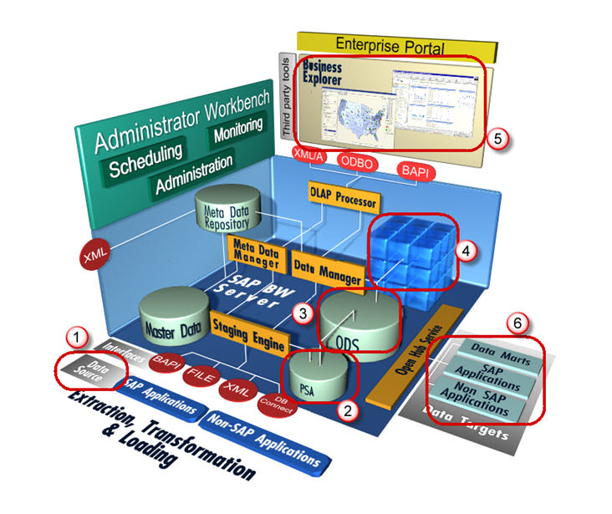

**All About Infoobject Infoarea & Infoobject Catalog**

**Details**

Last Updated: Sunday, 04 September 2016 16:00

**What is an InfoObjects?**

Info-Objects take information from the source, then adjust and arrange the information into either a standard or customized report.  Infoobjects are the smallest available information modules/fields in BI. **It is needed in info-providers like InfoCubes, DSOs, MultiProviders, Queries etc...  These Info-Providers are made up of Info-objects.**

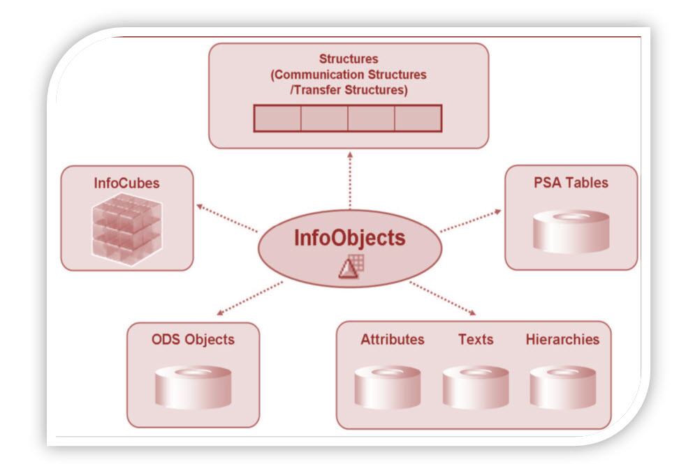

Info-object gives all information about the business. For instance company ‘XYZ’ is interested in finding out how much of “product x” shipped on “date x” to “factory x”.  By defining Info-object for specific function like “0MATERIAL”, “0DATE” and “0LOCATION” all the information can be retrieved.

InfoObjects can be classified into the following types:

* Characteristics (for example, customers)
* Key figures (for example, revenue)
* Units (for example, currency, amount unit)
* Time characteristics (for example, fiscal year)
* Technical characteristics (for example, request number)

**Characteristics:**

Characteristics are Business reference objects used to analyze key figures.

Examples of characteristics InfoObjects:

* Cost center (0COSTCENTER)
* Material(0MATERIAL)

**Keyfigures:**

Key figures provide the values to be evaluated. They are numeric information that is reported in the query.

Examples of key figure InfoObjects:

* Quantity (0QUANTITY)
* Amount (0AMOUNT)

**Units:**

Units are paired with Key figure values . They provide assign a unit of measurement to a Key Figure Value. For instance 10 Kg where 10 is the KeyFigure and Kg is the unit

Other Examples of Unit Characteristics:

* Currency unit (0CURRENCY) (Holds the currency type of the transaction e.g. $, EUR, USD...)
* Value unit (0UNIT)  (or) unit of measure (Hold the unit of measure e.g. Gallon, Inch, cm, PC)

**Time Characteristic:**

Time characteristics give time reference to data.

Examples of Time Characteristics:

* Calendar day (0CALDAY)
* Calendar year (0CALYEAR)
* Fiscal year (0FISCYEAR)

**Technical Characteristics:**

Technical characteristics are SAP standard objects having their own administrative purposes.

Examples of Technical Characteristics:

* Info Object 0REQUID – While loading data to various data targets,  SAP allocates unique numbers which are stored in this Info object
* Info Object 0CHNGID – When aggregate change run is done, a unique number is allocated and stored in this info object.

**Before creating an Info Object, Info Area and Info Object Catalog need to be created.**

**What is an InfoArea?**

* In Business Warehouse, Info-areas are the branches and nodes of a tree structure.
* It is used to organize info cubes and info objects.
* Each Info-object is assigned to an Info Area.
* Info Area can be thought of as a folder used to hold related files together.

**What is Infoobject Catalog?**

* Every info object need to be created within an Info Object Catalog.
* It helps in organization and is no way related to reporting functions.
* Example: There are tons of InfoObjects for SAP Financials which can be clubbed into a InfoObject Catalog.  This makes management and maintainence easy.
* An Info Object can be assigned to multiple Catalog

There are 2 types of Info Object Catalog.

1. Characteristic Info Object Catalog
2. Key figure Info Object Catalog

**Here is the RoadMAP to create an Infoobject**

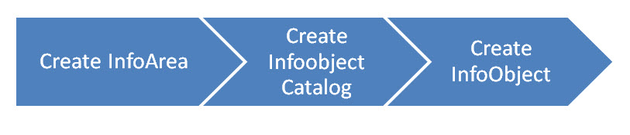

**How To Create an Infoarea?**

**Details**

Last Updated: Sunday, 04 September 2016 16:00

**Step 1)**

1. Go to transaction code RSA1 to go to the Data Warehouse Workbench.
2. Click the OK button.

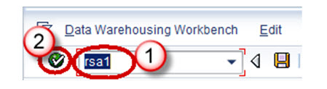

**Step 2)**

1. Navigate to Modeling ->InfoProvider
2. Right click in the Workbench and Create an InfoArea

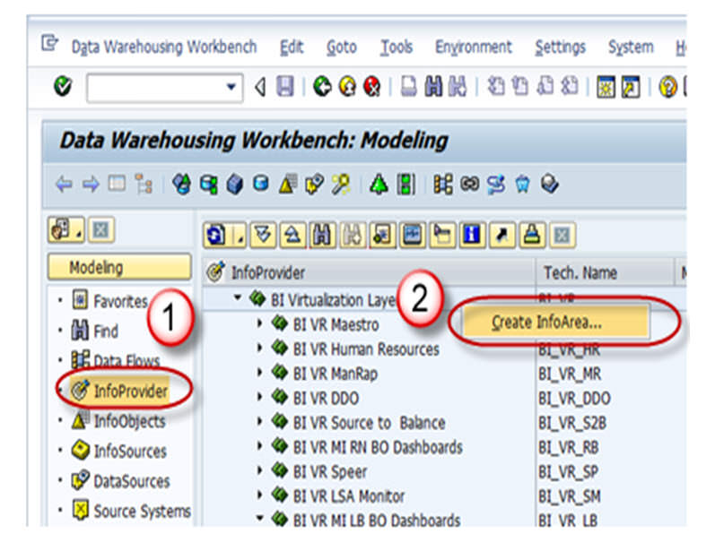

**Step 3)**

1. Enter the Technical Name
2. Enter the Description
3. Press the enter button

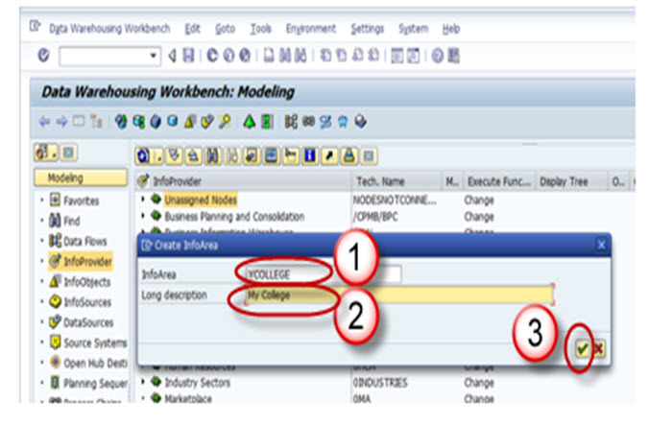

**Step 4)**

The Info Area created appears as shown below.

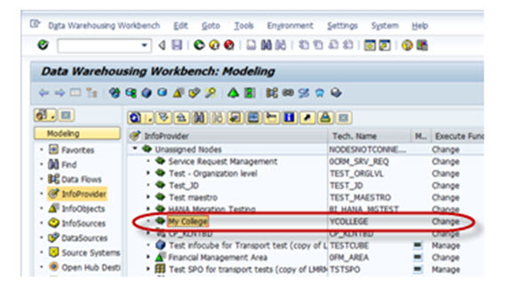

**How To Create an InfoObject Catalog**

**Details**

Last Updated: Sunday, 04 September 2016 16:00

**Step 1)**

1. Go to transaction code RSA1 to go to the Data Warehouse Workbench.
2. Click the OK button.

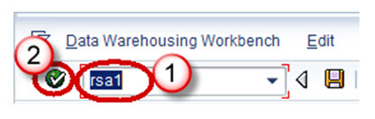

**Step 2)**

1. Navigate to Modeling -> Infoobjects
2. Right click on the Info Area and choose the option “Create InfoObject Catalog” as shown below

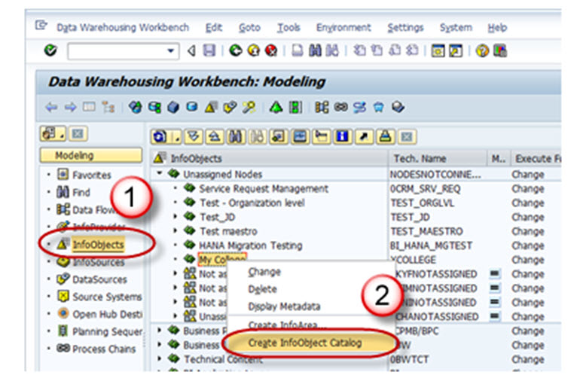

**Step 3)**

1. Enter the Technical name of the InfoObject Catalog.
2. Enter the Description of the InfoObject Catalog.
3. Click in the “Characteristic InfoObject” option button. This is a characteristic InfoObject Catalog. Click the Keyfigure option button. Then a Keyfigure InfoObject Catalog would be created.
4. Click on the create button.

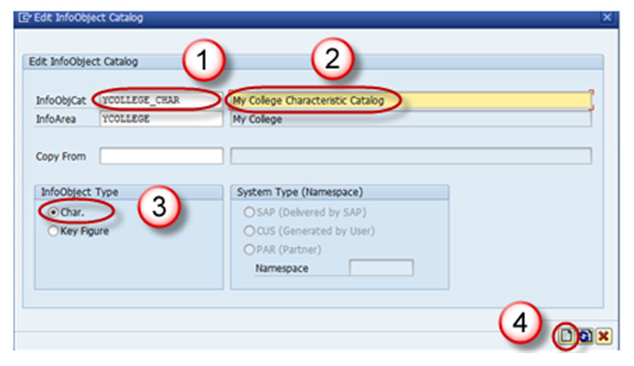

Save and Activate the InfoObject Catalog. The InfoObject Catalog created appears as shown below.

